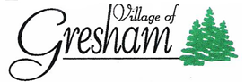
1126 Main St. PO Box 50
Gresham WI 54128
715-787-3244

JOINT REVIEW BOARD MEETING
TAX INCREMENT FINANCING DISTRICTS
WEDNESDAY, JUNE 21, 2023, AT 9:00 A.M.
VILLAGE HALL
801 MAIN STREET
GRESHAM, WI 54128

AGENDA:

- Call to Order

- Roll Call

- Approval of Minutes from the June 22, 2022, Joint Review Board Meeting additions or corrections if necessary.

- Appointments (as needed):

- Review Annual PE-300 Report and the performance and status of Tax Incremental District No. 1.

- Review Annual PE -300 Report and the performance and status of Tax Incremental District No. 2.

- Adjourn

Posted at: Abby Bank Posted Date: June 14, 2023, Gresham Village Hall Time: 1:00 p.m.
Gresham Post Office
Posted by Judith Kristof

